# **[Demo 4: How to use Arduino ESP32 to display information on I2C LCD](http://www.iotsharing.com/2017/05/how-to-use-arduino-esp32-to-display-i2c-lcd.html)**

**1. Introduction**  
This tutorial show you **how to connect a LCD module to Arduino ESP32** via LCM1602 module to display information from ESP32. There are 2 ways to connect ESP32 to LCD module:

Connect directly. By using this way, ESP32 will waste 7 GPIO pins (4 GPIO pins for data transfer and 3 GPIO pins for LCD control).

Connect via LCM1602 module. By using this way, ESP32 will only use 2 GPIO pins which act as I2C SDA and SCL pins. LCM1602 will be responsible for converting I2C data to LCD data and control signals.

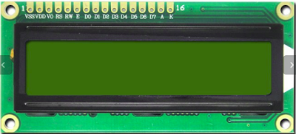

**Figure: LCD 16x02 module**



**Figure: YwRobot LCM1602 module**

**Note: the I2C address of LCM1602 is 0x27**  
**2. Hardware**  
Next we connect the pins of ESP32 to LCD module:

[ESP32 GPIO12 - LCM1602 SDA]

[ESP32 GPIO14 - LCM1602 SCL]

[ESP32 GND - LCM1602 GND]

[LCM1602 - 5V]

 or follow the picture below:

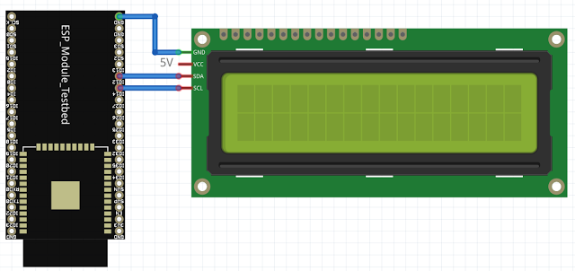

**Figure: connect ESP32 to LCM1602**

**3. Software**  
We will use the library **LiquidCrystal_I2C** that is made for Arduino but I modified a little to compatible with ESP32. You can download the library here:

[https://github.com/nhatuan84/esp32-lcd](https://github.com/nhatuan84/esp32_lcd)

After downloading, unzip and copy the unzipped folder under folder:

**[C:/Users/[YOUR_USER_NAME]/Documents/Arduino/libraries](https://www.blogger.com/null)**

The library supplied some functions:

**begin(sda=-1, int8_t scl=-1)**: to initialize library and I2C pins, sda is ESP32 GPIO pin connect to LCM1602 SDA, scl is ESP32 GPIO pin connect to LCM1602 SCL.

**backlight()**: to turn on backlight

**setCursor(uint8_t col, uint8_t row)**: set cursor at column and row (16x02: 2 rows [with index from 0 to 1] and 16 cols [with index from 0 to 15])

**print(char s[])**: print the string s to LCD

In order to use these functions you need to create an instance of LiquidCrystal_I2C:

**LiquidCrystal_I2C(uint8_t lcd_addr, uint8_t lcd_cols, uint8_t lcd_rows, uint8_t charsize = LCD_5x8DOTS);**

with:

lcd_Addr: is the I2C address of LCD, in this case it is 0x27.

lcd_cols: is the number of columns of LCD, it is 16.

lcd_rows: is the number of rows of LCD, it is 2.

charsize = LCD_5x8DOTS: is the size of one character. Default value is 5x8 dots.

so it look like this:

**LiquidCrystal_I2C lcd(0x27, 16, 2);**

and 

**lcd.begin(12, 14);**

it means ESP3 GPIO12 is connected to LCM1602 SDA and ESP32 GPIO14 is connected to LCM1602 SCL

Finally, you create an Arduino project and save it as **esp32lcd** with code:

|  |
| --- |
| #include <Wire.h>  #include <LiquidCrystal_I2C.h>  LiquidCrystal_I2C lcd(0x27,16,2);//set the LCD address to 0x27 for a 16 chars and 2 line display  void setup(){  lcd.begin(12, 14);// initialize the lcd with SDA and SCL pins  // Print a message to the LCD.  lcd.backlight();  lcd.setCursor(0,0);  lcd.print("Hello, world!");  lcd.setCursor(0,1);  lcd.print("by EasyIoT");  }  void loop(){  } |

1. **Result**

